Sampling guide: SmoltVision

For sampling of realtime RT-PCR samples the following equipment is recommended to have available:

- Barcode tubes with RNA-later from PHARMAQ Analytiq
- Anesthetic
- Styrofoam box for shipping
- Cooling elements
- Tweezers, scalpel and/or surgical scissors.
- Clean surface
- Paper for cleaning
- Requisition form and barcode form
- Weight scale
- Length measurer

If the samples are to be used for gill pathogen analysis as well, it is required that sterile technique is used when the fish is sampled. This is to avoid cross-contamination of the samples.

In the sampling kit from PHARMAQ Analytiq you are supplied with a requisition form for analysis and a barcode form. We recommend that you fill in the barcode form parallel with the sampling.

Size of sample tissue:

The gill samples should be 3x3x3 mm in size. The correct size of the sampled tissue can be compared to the size of a large match head. It is very important that the whole tissue sample is covered with the fluid in the sample tubes for preservation of the tissue.

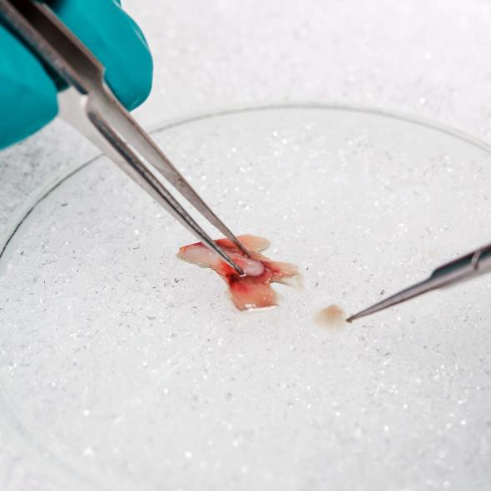
Procedure:

- Euthanize the fish with anesthetic
- Write down weight, length and smolt index for the individual you are sampling. Write down any deformities or signs of disease in the comment section.
- Find the 2nd gill arch and use the tweezers to hold the cartilage
- Cut out the whole gill arch
- Place the gill arch on a clean surface
- Cut out a piece of gill tissue (3x3x3mm) from the bend in the gill arch (no cartilage)
- Put the tissue in the sampling tube with RNA-later.
- Dry of the scalpel/scissor before sampling the next fish.
- Samples are stored in the refrigerator for 24 hours before freezing, or they can be sent without freezing to PHARMAQ Analytiq, with sufficient amounts of cooling elements inside the package.

Samples should be sent with express delivery to PHARMAQ Analytiq:

PHARMAQ Analytiq
Thormøhlensgate 53D
5006 Bergen

