Sampling and shipping guide for realtime RT-PCR samples

Equipment recommended to have available when sampling realtime RT-PCR:

- Ovarian fluid/milt and ova: barcode tube containing RLT-buffer
- Fry/tissue: barcode tube containing RNAlater
- Styrofoam box
- Cool packs
- Forceps and scalpels
- Gas burner for sterilization forceps and scalpels
- Clean surface for trimming tissue samples
- Tissue paper

The package with barcode tubes from PHARMAQ Analytiq contains a realtime RT-PCR submission form. We recommend that you fill in the form as the samples are being taken.
The barcode tubes should be placed back in the rack after sampling, preferably sorted by tissue type. Empty racks are sent out upon request.

NB Different tissues should not be placed in the same sampling tube, as this can lead to the wrong tissue being used for analysis. It can also cause contamination between tissues. Use one sampling tube per tissue being sampled.

All samples should be registered electronically in our customer portal before shipment.

Sampling Guide for Hatchery Sized Fish and Growers:

Sampling for real RT-PCR should be performed using sterile technique to ensure that contamination is avoided.

- Use paper to remove tissue residues from the scalpel
- Use a gas burner to sterilize the scalpel blade and forceps between different tissues and individuals
- The sterile interior of the scalpel blade packaging can be used as a surface to trim tissues on
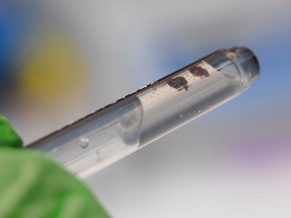
- Contact between head kidney/heart tissue samples and the abdominal cavity should be avoided
1

The tissue samples should be the size of a match head, 2x2x2mm. It is important that the tissue samples are properly immersed in the conservation fluid in the sample tubes (1).

ALEVINS: Place the whole alevin in a tube with RNAlater
LARGER FRY: The head is cut just behind the operculum, and if necessary, can be cut in half before being placed in a tube with RNAlater. It is important to include gills, heart and kidney in the section.

SMOLTS/GROWERS:
01. Gill (arch number 2) and skin should be sampled first (2A, 2B and 2C)
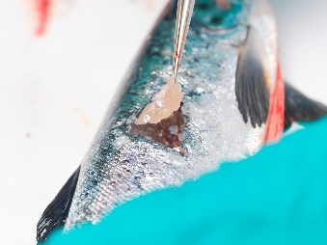
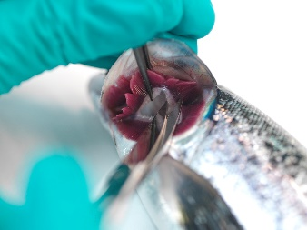
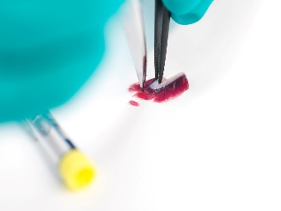
02. Place the tissue on a clean surface and split each sample in two pieces of similar size. (A- and B sample) Put both samples (of the same organ) into a tube containing RNAlater
2C
2A
2B

03. Sterilize the scalpel blade and tweezers before making a cut into the heart cavity. Use the forceps to pick up the heart by the bulbus area (3)
04. Place the heart on a clean surface and cut off the apex, split the apex in two and put both samples in a tube containing RNAlater
05. Any tissue residues should be removed from the instruments which should then be sterilized before making a cut in the abdominal cavity (4)
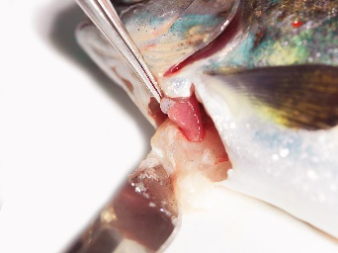
06. The kidney should be the first organ sampled from the abdominal cavity. Identify the kidney by removing the swim bladder. Sterilize the instruments again before extracting a small square from the head kidney. Split the extracted square in two and put both samples in a tube containing RNAlater (5)
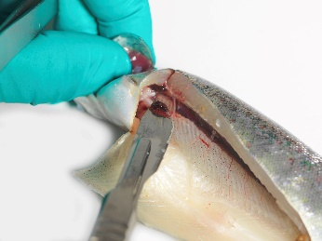
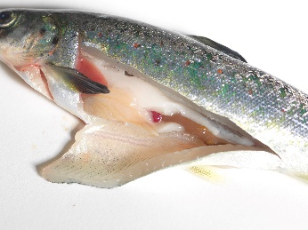
3
5
4

07. After sampling one individual the
08. When sampling is finished the order form should be completed.
09. Make a note on the barcode sheet if additional information regarding the tubes (i.e. cage, wound, healthy) needs to be included
10. Place the sample tubes in a strong envelope together with order form, barcode sheet, and a cooling element. The samples should be sent using express delivery. (6)
11. For storing of samples over a longer period before submission the samples should be stored overnight in fridge to ensure proper fixation. Then the samples should be stored in freezer.

Regular Screening
When doing regular screening we recommend to sample moribund and/or freshly deceased individuals until a positive RT-PCR sample is detected. After a pathogen has been detected in moribund/dead fish screening of random healthy individuals should follow to get an overview of the prevalence in the population.
Sampling Guide for Brood Fish
Sampling for realtime RT-PCR should be performed using sterile technique to ensure that contamination is avoided.

OVARIAN FLUID/MILT: Minimum 0,2 ml and maximum 1 ml ovarian fluid/milt in a tube containing RLT-buffer. Do not pool ovarian or milt samples from several individuals in the same tube.
OVA: One ovum per tube

For ovarian fluid, milt and ova samples sampling tubes containing RLT buffer should be used. If the samples are sent within 24 hours the tubes can be stored in the fridge. If the samples are stored for longer than this it should be done in a regular -20°C freezer. It is very important to ensure proper cooling during transportation, as multiple thawing and freezing can affect sample quality.

If anything is unclear – please contact us!

Ship the samples with express delivery:

PHARMAQ Analytiq AS
Thormøhlensgate 53D
5006 Bergen
Norway

